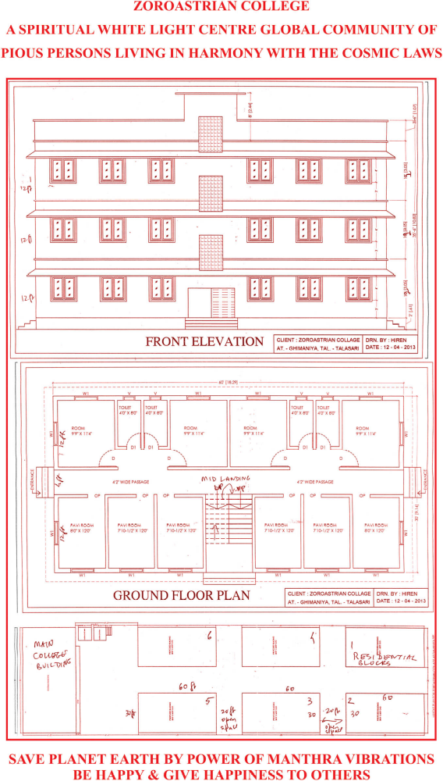 ZOROASTRIAN COLLEGE BUILDING
CONSTRUCTION FUNDS APPEAL

The Governing Body of All India Shah Behram Baug Society THANKS ALL THESIS CANDIDATES & EACH AND EVERY PERSON WHO HAS CONTRIBUTED FOR THE CONSTRUCTION OF MEZZANINE FLOOR During April-October 2012. AND SPECIAL THANKS TO DR. AJIT KUMAR SINGHJI KASLIWAL, DR. DAVISH JAIN, DR. MRS. ANUPAMA JAIN, DR. MANMATH PATNI, DR. M. K. OZHA AND INDORE CENTRE FOR CONSTRUCTION OF THE NEW HALL opened on 4th February 2013

The next phase of construction work is 6 residential buildings of 6 flats each
Purpose: To create a living White Light Centre for you and good persons like you from all countries to live together happily as a community. The ground floor is designed for performance of pooja (Yasna and Yagna ceremonies) by residential pujaris/good persons.

The first and second floors are residential flats – about 900 sq. ft. plinth area each – 2 flats per floor. The present booking price is EUROS 36000/- per flat. Two persons or a family can share a flat. You can have permanent right of abode in a flat; and pass it on to your children/grand children/family members. Please inform others.

The first building construction commenced in March 2014 – target for completion is March 2016. Completing the Project in time entirely depends on YOU and all good persons willing to lend a helping hand

The Fund Raising Target is Rs.96 lakhs (Rs. 96,00,000/-) per building.

The Construction Project. Would YOU PLEASE CONTRIBUTE whatever you wish to:
- BRICK DONATION – Rs. 1000/- (Rupees One thousand per brick)
- CEMENT & STEEL DONATION - Rs.5000/- to Rs.10,000/-(Rupees five thousand to Rupees Ten thousand)
- GENERAL CONTRIBUTION BETWEEN Rs. 10,000/- TO 1,00,000/- (Rupees Ten thousand TO Rupees One lakh only)
- ONE FLAT(2 BEDROOM 2 BATHROOM about 900 sq. ft. plinth area) – Rs. 25,00,000/- (Rupees Twenty five lakhs only)
- ALL DONATIONS in cash or BANK DRAFT - in favour of SHAH BEHRAM BAUG SOCIETY are TAX EXEMPT UNDER SEC. 80G OF I.T. ACT in India
- PLEASE USE THE CONTRIBUTION FORM BELOW

ZOROASTRIAN COLLEGE BUILDING CONSTRUCTION APPEAL

Thanks to the support given by some of the past students and well wishers, the College building construction work is proceeding slowly and steadily

YOUR KIND SUPPORT AND GENEROUS CONTRIBUTION IS REQUESTED.
ALL DONATIONS ARE TAX EXEMPT under section 80G of Income Tax Act in India.
Please do speak to your circle of friends/companies/other persons who would be interested willing and able to lend a helping hand to complete this project

MAIN ADVANTAGES OF STAYING IN THIS SPIRITUAL CENTRE
YOU ARE HELPING TO SAVE PLANET EARTH

*1. CLEAN WATER – DR. VICTOR INYUSHIN’s Kazakh Technology
2. HEALTH- GIVING ENVIRONMENT
3. NATURAL GREENERY SURROUNDINGS IN COUNTRYSIDE ON RIVER BANK
4. SPIRITUAL RESIDENTIAL CENTRE WITH GOOD fresh food
LIBRARY FACILITIES for research world wide, on topics of your choice and interest
5. EDUCATED CLASS OF PERSONS - BOTH INTERNATIONAL & NATIONAL
6. EASY ACCESS BY ROAD AND TRAIN (about 3 hours from Mumbai
7. PEACEFUL SPIRITUAL place to have your abode and live with loving and harmonious persons, in a happy group of like- minded persons.
........................................................................................................................................
CORPUS DONATION FORM FOR BUILDING CONSTRUCTION
SHAH BEHRAM BAUG SOCIETY

Name………………………………………………………………………………………………..

Res.Address………………………………………………………………………………………..

………………………………………………………………………………………………………

Tel: Res…………………………Off…………………………….Mob…………………………...

Email……………………………………………………………………………………………….

I am contributing Rs.………../Rupees ………….. …………………………………………...
for lending my helping hand for this project to SAVE PLANET EARTH.
Please find enclosed my Bank Draft payable on any bank in Mumbai in favour of
SHAH BEHRAM BAUG SOCIETY
Name and address of issuing bank……………………………………………………………………………….
Bank draft no. And date …………………………………………………………………………………………….
Please send me the official section 80G tax exempt donation receipt.

Signature………………………………..

Date……………………………………..

(NAME OF YADGARI DONATION DEPARTED PERSON WHERE APPLICABLE)

...................................................................................................................................................

YADGARI DONATIONS

Persons giving contributions of Rs.50,000/- (Rupees fifty thousand) and over are entitled to have a portion of the building named in honour of any dear departed family members or friends. The name of the donor and Yadgari departed person will be inscribed permanently on the Roll of Honour of the building. Also prayers ceremonies for the departed souls are performed daily in the College building. The name of the Yadgari departed person will be included in the daily prayers names list. The name will also be included in the annual Navroze Jashan ceremony.

